Vertical well Test DStabor coupling, steering, interpretation,visualization

Type: Post
Tested functionality: Coupling Dstabor for Vertical well
Model, mesh Horizon/Hexa
Formation: linear
Result: Optimum mudweight
Class: GUI/mechanical/comparison to theory}
Since GEOMEC version: 3.2

Test description (more detailed)
Automatic selection of points along the wellpath.
Starting a optimum mudweight calculation
Values of calculation checked

Figure model:
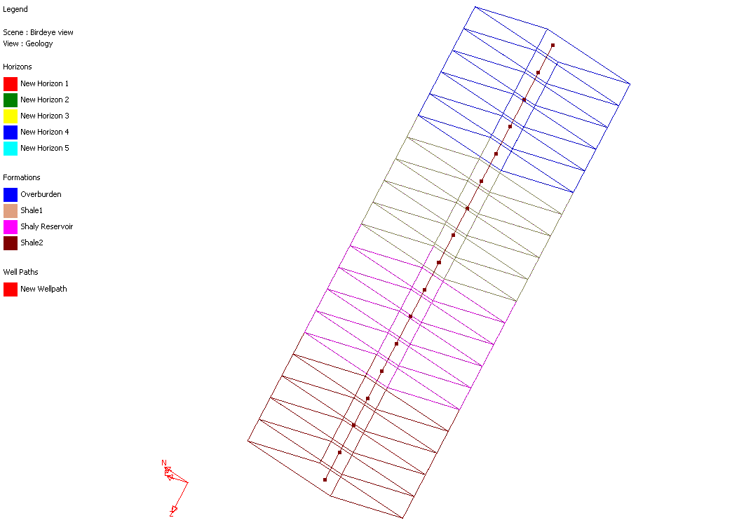

Directories for input and output files:
sourcesafe path: Test/Post/Wellpath/Dstabor ccoupling/vertical wellpath

Results

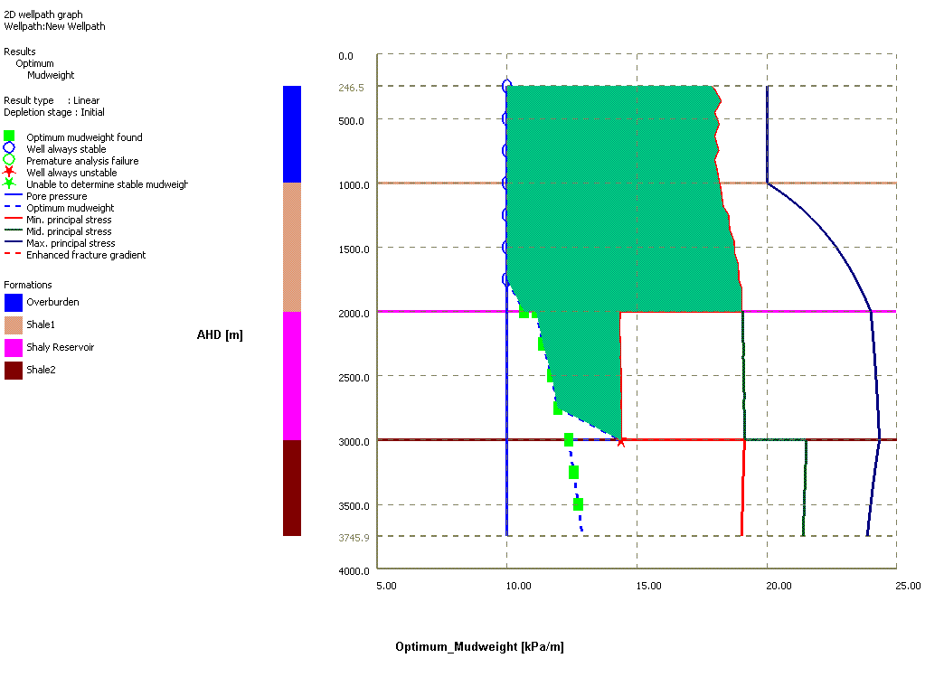

AHD  [m ] | TVD  [m ] | P0  [kPa/m ] | OMW [kPa/m ] | SMIN [kPa/m ] | SMED [kPa/m ] | SMAX [kPa/m ]
250.05 | 250.05 | 10 | 10 | 17.875225 | 4.4697 | 5.001
500 | 500 | 10 | 10 | 18.0625 | 9.03125 | 10
749.95 | 749.95 | 10 | 10 | 18.124942 | 13.5928 | 14.999
999.9 | 999.9 | 10 | 10 | 18.156166 | 18.15435 | 19.998
1000.1 | 1000.1 | 10 | 10 | 18.168833 | 18.17065 | 20.0028
1250.05 | 1250.05 | 10 | 10 | 18.50502 | 23.1322 | 27.0014
1500 | 1500 | 10 | 10 | 18.729167 | 28.09375 | 34
1749.95 | 1749.95 | 10 | 10 | 18.889283 | 33.0553 | 40.9986
1999.9 | 1999.9 | 10 | 10.660278 | 19.009375 | 38.01685 | 47.9972
2000.1 | 2000.1 | 10 | 11.125802 | 14.328121 | 38.15815 | 48.0025
2250.05 | 2250.05 | 10 | 11.386077 | 14.34722 | 42.9697 | 54.25125
2500 | 2500 | 10 | 11.722758 | 14.3625 | 47.78125 | 60.5
2749.95 | 2749.95 | 10 | 11.950837 | 14.375002 | 52.5928 | 66.74875
2999.9 | 2999.9 | 10 | 14.385421 | 14.385421 | 57.40435 | 72.9975
3000.1 | 3000.1 | 10 | 12.371575 | 19.131246 | 64.520887 | 73.0022
3250.05 | 3250.05 | 10 | 12.567944 | 19.094229 | 69.776069 | 78.5011
3500 | 3500 | 10 | 12.744585 | 19.0625 | 75.03125 | 84
3749.95 | 3749.95 | 10 | 12.902107 | 19.035 | 80.286431 | 89.4989

